**Biology: Bioenergetics Midterm Study Guide**

**Due: Thursday 2/15 or Friday 2/16**

**Vocabulary (**d**efine each of these in *your own words*):**

* Enzyme
* Active site
* Activation Energy
* Substrate
* Catalyst
* pH
* ATP
* Chlorophyll
* Chloroplast
* Glycolysis
* Light Reaction
* Dark Reaction
* Photosynthesis
* Cellular Respiration
* Anaerobic Cellular Respiration
* Aerobic Cellular Respiration

**Enzymes:**

1. What are typically the last three letters of an enzyme’s name?

Answer the following questions about the graph below:

1. What does the graph show?
2. Are the enzymes increasing or decreasing the activation energy?

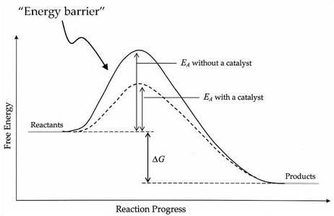

Answer the following questions about the graph below:

1. When does the enzyme below work best?
2. What happens to the enzyme in Part IV?



1. Write when both gastric protease and intestinal protease work best according to the graph below.



Gastric Protease:

Intestinal Protease:

1. What are three factors that influence the activity of enzymes?
2. How do these three factors influence the activity of enzymes?
3. What is the active site?

**pH Scale:**

1. What does the pH scale measure?
2. What would be a strong acid and what is the atom that makes it an acid?
3. What would be a strong base and what are the atoms that make it a strong base?

**Macromolecules:**

Complete the following chart:

|  |  |  |  |
| --- | --- | --- | --- |
| **Compound** | **Elements Present** | **Function** | **Building Blocks** |
| Carbohydrates |  |  |  |
|  | C, H +O |  |  |
|  |  | Structure |  |
|  |  |  | Nucleotides |

**Photosynthesis:**

1. What is the chemical reaction for photosynthesis? Please write the words as well as the equation.
2. Where does photosynthesis occur in the cell?
3. What colors of white light are absorbed in photosynthesis? How do you know?
4. What colors of white light are reflected in photosynthesis? How do you know?
5. What happens during photosynthesis in a dark reaction?
6. What are the products of the dark reaction process?
7. What happens during photosynthesis in a light reaction?
8. What are the products of the light reaction process?
9. What would happen to a plant that was grown with only green light?
10. What does the following graph describe about light absorption and reflection in a plant?



Answer the following questions about the graphic below:



1. What are the bubbles of gas being made from the plant?
2. What process is making these bubbles of gas?
3. After these bubbles of gas are made, what is the next process that occurs?
4. What molecule is made during this process to make energy?

**Cellular Respiration:**

1. What is the chemical reaction for cellular respiration? Please write the words as well as the equation.
2. How is ATP made in cellular respiration **and** how much?
3. What is the cycle for ATP?
4. What are the two types of cellular respiration? Which makes more energy?
5. Where does glycolysis occur and what is it for?
6. What causes anaerobic respiration?
7. What happens during anaerobic respiration?
8. What happens during aerobic respiration?

Please answer the following questions about the chart below:

1. What process is being shown in the picture below?

Answer the following questions about the graphic below:

1. Where does the picture below take place in the cell? (Hint: it doesn’t look like the real structure.)
2. What is the chemical equation for this process?



1. Compare and contrast the differences between cellular respiration and photosynthesis.