Name:__________________________

Geologic History/Dating Exam Study Guide

Vocabulary (define the following in your own words):

half life

Charles Lyell

geologic time scale

strata

lithification

radioactive decay

period

era

fossil correlation

law of superposition

original horizontality

unconformity

mass extinction

relative dating

uniformitarianism

de-extinction

epoch

absolute dating

disconformity

nonconformity

angular unconformity

Concepts to study:
- What is lithification and how can it help create the geologic time scale?

- Compare and contrast relative and absolute dating.

- Look at the Precambrian Era and compare it to the Paleozoic Era. Why is the Paleozoic broken into more periods even though the Precambrian Era is a much longer section of Earth’s history?

- Describe how studying the geologic time scale can help someone have a more in-depth understanding of the evolution of life.

- Why is uniformitarianism important to geology?

- Why do scientists need a geologic time scale?

- Explain how fossils provide evidence to Earth’s past.

- When did geologic time begin?

- What era are we currently in? What period?

- List the eons

- Explain why scientists know more about the Cenozoic than they do about other eras.

- Which period is known as the age of fish? Which periods were dinosaurs dominant? Which era did mammals occur in?

- Rank the divisions of time from shortest to longest: Eon, Period, Epoch, Era.

- Distinguish among eons, eras, periods, and epochs, using specific examples.

- What is the most common radioactive element when it comes to absolute dating rocks?

- Compare and contrast a nonconformity, angular unconformity, and a disconformity (draw pictures and label please)

- How do we use rock layers to determine geologic history?

- If a fossil is found in a rock layer, what do we know about the relative age of the fossil?

- How do geologists use the fossil record to determine geologic history?

- What major (extinction) event on the geologic timeline occurred most recently?

- How are radioactive elements used to date rocks and other objects?

- What are the differences between absolute age dating and relative age dating?

- What is de-extinction and in what circumstance should it be done?

- What type of rock are fossils typically found in?

- Be able to apply the principles of geology as well as construct a rock column that includes fault/intrusions and order your drawing from youngest to oldest.

- Please order this picture from youngest to oldest and explain what happened.

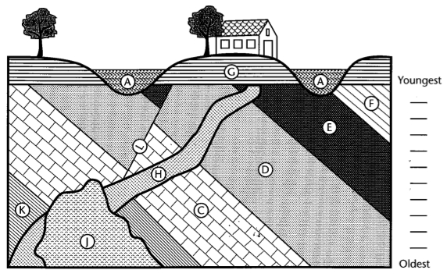

- What principles of geology are being used in the diagram below?

