Name:

Period:

**Genetics Study Guide**

***DNA:* Vocabulary –** write definitions for each of the terms:

* DNA
* RNA
* DNA Synthesis
* Nucleotide
* Transcription
* Translation
* Gene-Point Mutation
* Chromosomal Mutation

What is this structure on DNA called?

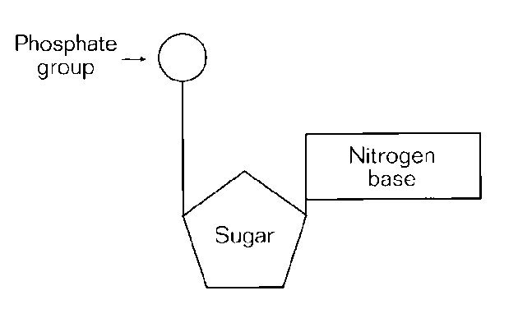

*Be sure you know:*

1. What happens in DNA Synthesis and where does DNA Synthesis occur?
2. What happens in RNA Transcription and where does transcription occur?
3. What does mRNA connect with in the cytoplasm?
4. What happens in RNA Translation and where does translation occur?
5. What type of bond connects the Nitrogen base pairs in a strand of DNA?
6. In DNA, Adenine forms hydrogen bonds with ____________, and Guanine with __________.
7. In RNA, the base _______ replaces the base thymine.
8. Label the missing nitrogen bases in this DNA molecule below. Circle the nucleotides. How many nucleotides are there? _________

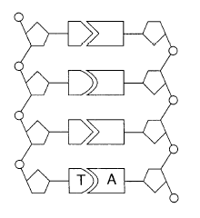

1. Is this molecule at left DNA or RNA? How do you know?



1. Determine the amino acid chain using this chain of DNA: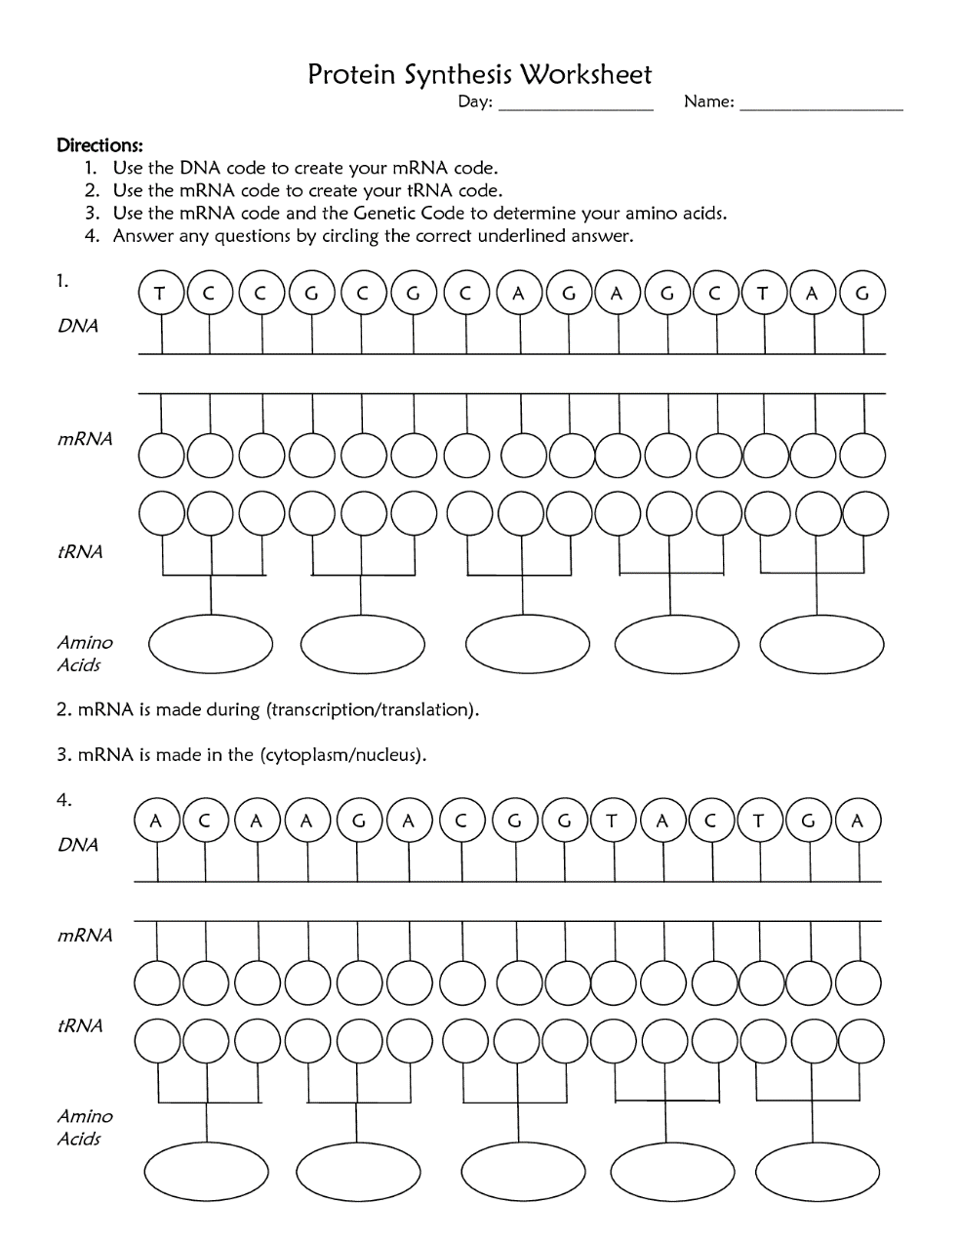
2. Compare and contrast RNA and DNA. What do they have in common and what is different?
3. What are all of the steps of mitosis?
4. What are all of the steps of meiosis?
5. Compare and contrast mitosis and meiosis.
6. Are gametes haploid or diploid?
7. What does this karyotype show (male/female?… genetic mutations?… etc.) :



**Genetics**

Vocabulary:

* Phenotype
* Haploid
* Diploid
* Genotype
* Dominant trait
* Incomplete dominance
* Codominance
* Recessive trait
* Allele
* Heterozygous
* Homozygous
* Sex-linked trait

Questions:

Having freckles on your face is a dominant trait. Use the following alleles for freckles to answer the series of questions below:

F = dominant trait – has face freckles

f = recessive – has no face freckles

1. If a person does not have face freckles, what is their genotype for freckles?
2. If a person has face freckles, what are their possible genotypes?
3. Jack is heterozygous for face freckles. What is his phenotype?
4. Jack gets marries to Diane who does not have freckles on her face. What is the probability that their first child will have freckles? Fill in the Punnett square below to determine probability:

|  |  |
| --- | --- |
|  |  |
|  |  |

1. Here is Jack and Diane’s genetic pedigree for freckles. Family members with freckles are shaded in black. Fill in the genotype (FF, Ff, ff) for each member in the family above the square or box:

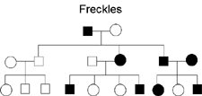

This pedigree is showing inheritance of a disease:

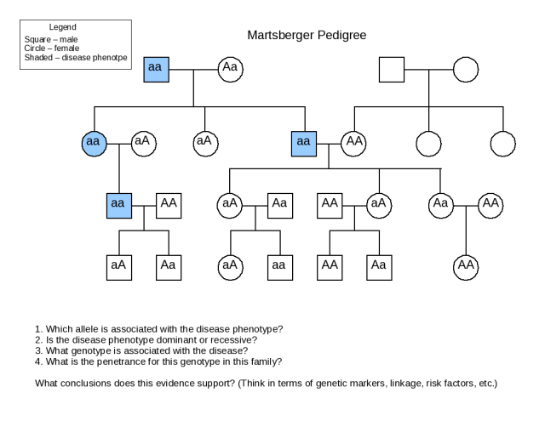

1. Which allele is associated with the disease phenotype?
2. Is the disease phenotype dominant or recessive?
3. What genotype is associated with the disease?
4. What are autosomes and sex chromosomes and how many of them do the average people have.
5. What is co-dominance? How is it different from incomplete dominance?
6. Why are men more likely to be color blind than women?
7. Three Babies Were Recently Mixed Up In a Hospital. The Blood Types Of The Possible Parents And Babies Are Shown Below:

PARENTS I PARENTS II PARENTS III

A and B A and A AB and O

BABY 1 BABY 2 BABY 3

Type B Type O Type AB

Use Punnett squares to find out the possible parents of baby 1, baby 2, and baby 3.