Geologic Time and Rock Dating Guided Notes
Geologic Time Scale:

What is the Geologic Time Scale?
Definition:

Scientists placed Earth’s rocks in order by _______________________ to create the geologic column.

We developed the scale by studying these rock layers and ______________________.

______________________________ helped us determine the _________________________ of the divisions in the scale.

Divisions of Time:
As scientists studied the fossil record, they found major changes in life forms at certain times.

_________________________________________________________________________________________
_________________________________________________________________________________________

_________________________________________________________________________________________
_________________________________________________________________________________________

Eon:

Era:

Period:

Epoch:

Why is a time scale used to represent Earth’s history instead of a calendar?

When did geologic time begin?

When does geologic time end?

How long is a geologic period?

Eons:

Hadean:

Archean:

Proterozoic:

Phanerozoic:
Eras:
Paleozoic:

Mesozoic:

Cenozoic:

Periods:
PAST

PRESENT
Cambrian – Explosion of life
Ordovician – 1st Vertebrates
Silurian – 1st Land Plants
Devonian – Age of Fish
Mississippian – Winged insects
Pennsylvanian – First reptiles
Permian – Age of Amphibians
Triassic – First Dinosaurs/Small mammals
Jurassic – First Birds/Flowering Plants
Cretaceous – Heyday of Dinosaurs
Tertiary – Mammals Thrive
Quaternary – Age of Man/Technology

Life Develops:
Describe the first lift, as well as when and where it is believed to have evolved.

Primordial Ooze:

When did photosynthetic organisms appear?

Mass Extinction
Occurs when __________________________________________________________________________
_____________________________________________________________________________________

1st Major Extinction:

2nd Major Extinction:

Relative vs. Absolute Dating

RELATIVE DATING

Uniformitarianism
_________________________________________________________________________________________

Laws of nature _____________________________________________________________________________

Past events ________________________________________________________________________________

Charles Lyell credited with this concept. Explained in his book “The Principles of Geology.”

Lithification: ______________________________________________________________________________
_________________________________________________________________________________________

Strata: _____________________________________

Relative Dating:____________________________________________________________________________
_________________________________________________________________________________________

4 Principles of Geology
- Original Horizontality:

- Law of Superposition:

- Cross-Cutting Relations:

- Fossil Correlation:

Not all sedimentary layers of rock are intact and complete. There are forces that cause layers “disappear” making the rock record is incomplete.

Unconformity: _____________________________________________________________________________

3 Types of Unconformities:
- Angular Unconformity:

- Disconformity:

- Nonconformity:

ABSOLUTE DATING

Absolute Dating:____________________________________________________________________________
_________________________________________________________________________________________

The Process of Radioactive Decay:

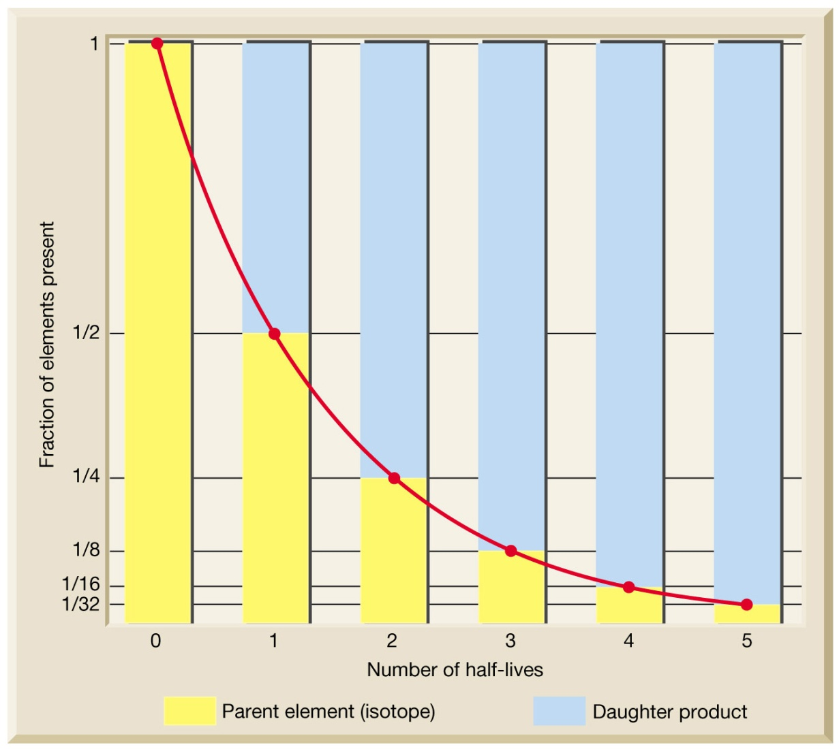

Half Life:

