Kepler’s Laws of Planetary Motion
Name: ________________________________________

Kepler’s First Law

Materials:
Foam board
Thumb tacks
White paper
String
Ruler
PENCIL!!!! Not a pen

Procedures:
- Fold the white paper in half, hot dog style.
- Use the ruler to draw a horizontal line across the width of the paper along the fold.
- Find the center of the horizontal line. Measure 5 cm to the left, draw a dot and label it A. Measure 5 cm to the right, draw a dot and label it B. Place the thumb tacks in each dot. These will be the position of the foci of the ellipse.
- Tie two ends of a piece of string together to make a loop. Make the knot so that when you stretch out the look with your fingers into a line, it is 12 cm long.
- Put the string over the two tacks and pull the loop tight using a pencil point.
- Draw an ellipse with the pencil. Do this by putting the pencil point inside the loop and then moving the pencil while keeping the string pulled tight with the pencil point.
- Draw a small circle around point A and label it “Sun.”
- Repeat the process explained in steps 3-6 using the following measurements and labels:
  - Two points 8 cm apart labeled C and D (1 cm inside of points A and B).
  - Two points 6 cm apart labeled E and F (2 cm inside points A and B).
  - Two points 4 cm apart labeled G and H (3 cm inside points A and B).
  - Two points 2 cm apart, labeled I and J (4 cm inside points A and B).
- Use the data table given to record the following measurements:
  - Measure the width (in centimeters) of ellipse (the circle you sketched) “AB” at its widest point. This is a the major axis, L. Record this in your data table.
  - Record the distance between the two foci, d (the distance between the two thumb tacks) for each ellipse in your data table.
  - The eccentricity E of an ellipse is equal to the distance between the two foci divided by the length of the major axis. Calculate the eccentricity of each of your ellipses using the equation E=d/L, where d is the distance between the foci and L is the length of the major axis. Record the eccentricity for each ellipse.
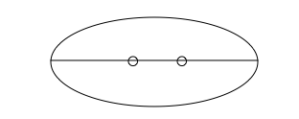

Data Table:
Ellipse | Major Axis  (L)  (cm) | Distance between the Foci  (d)  (cm) | Eccentricity  E=d/L
AB |  | 10
CD |  | 8
EF |  | 6
GH |  | 4
IJ |  | 2

Post-Questions:
- Describe the relationship between the distance between the foci and the eccentricity.

- Look at the ellipses as the orbits of planets around the Sun. Are any of the ellipses more like perfect circles? What causes this? (Look at your answer from question #1.)

- The lower the eccentricity, the more circular the orbit. Earth’s orbit has an eccentricity of about 0.017. Compare this value to the ellipse with the lowest eccentricity of those you drew. Why does it make sense to describe Earth’s orbit as “nearly circular”?

- Based on your understanding of Kepler’s First Law, explain why the distance from a planet to the Sun is typically given as an average distance.

Kepler’s Second Law
Kepler’s Second Law, the “Law of Equal Areas” states that a line drawn from the Sun to a planet sweeps equal areas in equal time, as illustrated on the diagram on the next page. A planet’s orbital velocity (the speed at which it travels around the Sun) changes as its position in its orbit changes. Its velocity is fastest when it is closest to the Sun and slowest when it is farthest from the sun.
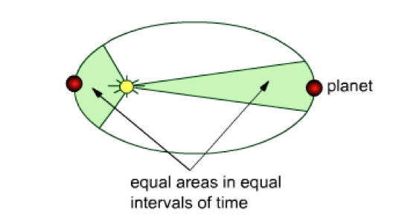
Area Y
Area X

- A planet’s orbital velocity is fastest at the position it its orbit called __________________ (perihelion/aphelion). During what season (in the Northern Hemisphere) is Earth at this position? ___________________________ Therefore, Earth moves ________________________ (faster/slower) in summer than in winter, so summer in the Northern Hemisphere must be ___________________________ (longer/shorter) than winter.

- Isaac Newton later determined that the force of GRAVITY holds the planets in orbit around the Sun. When a planet is closer to the Sun, the force of the Sun’s gravitational attraction on the planet is _________________________ (stronger/weaker) than when the planet is farther from the Sun.

- If Area X = Area Y on the diagram above, what can be inferred about the orbital velocities as the planet travels along its orbit through Area X compared to Area Y? (Which is faster?) Why? (Think about gravity.)

Kepler’s Third Law
Kepler’s Third Law, the “Law of Periods” relates a planet’s period of revolution (the time it takes to complete one orbit of the Sun) to its average distance from the Sun. Kepler determined the mathematical relationship between period and distance and concluded that the square of a planet’s period is proportional to the cube of its mean distance from the Sun. The formula used to determine this relationship for any planet is: T2 = R3, where T is the planet’s period in Earth years and R is the planet’s mean distance from the Sun in astronomical units (AU, where 1 AU equals the mean distance from the Earth to the Sun = 150 million km).
Sample Problem: Planet X has an average distance from the Sun of 1.76 AU. What is the planet’s period of revolution, in Earth years?
T2 = R3 T2 = (1.76)3 = 5.45 T =√ 5.45 = 2.33 Earth years
1. Calculate the period of revolution of each of the following planets.

Planet | Mean Distance to Sun (AU) | Period of Revolution (Earth years)
Mercury | 0.387
Mars | 1.524
Saturn | 9.539
Pluto | 39.440

2. Haley’s comet has an average distance of 17.91 AU from the Sun. Calculate the period of Haley’s comet. SHOW YOUR WORK BELOW!

